**Considering going solar? Think KinetEco!**

**5 Reasons to Go Solar**

1. 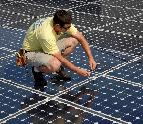**Protect the environment:** Solar is a 100% clean energy source
2. **Save money:** Cut your electricity bill and take advantage of tax credits and rebates
3. **Keep temperature** in your home at a comfortable 70°.
4. **Make money:** Sell excess energy back to the utility company
5. **Invest in your home:** Solar begins paying itself back immediately and has a life expectancy of 25 years
6. **Be a trend-setter:** Renewable, clean energy is the future

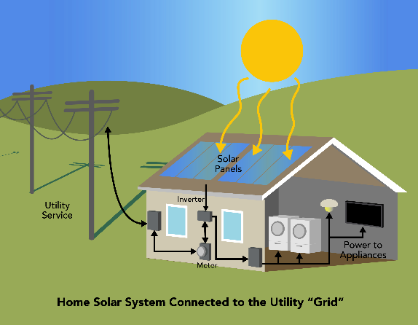

**How It Works**

1. Particles of light (photons) from the sun hit solar panels and are converted into electrons of DC electricity inside the photovoltaic cells.
2. The electrons flow out of the solar panels and into an inverter where they are converted into AC power that can be used in your home.
3. A net energy meter tracks all the power produced by the solar system.
4. At night, or on cloudy days, you’ll   
   consume energy from the grid, as normal.
5. During the day, under optimal conditions, you’ll consume electricity directly from the sun, as it’s generated.
6. Excess solar energy that you do not use goes back into the electrical grid, and is credited to your utility bill.

Why KinetEco?

KinetEco K-Eco© panels are the most efficient panels on the market, hands down!

Table 1- Panel Efficiency Rating

|  |  |  |  |  |  |  |
| --- | --- | --- | --- | --- | --- | --- |
| PANEL MODEL | PTC(Watts) | AREA (SqFt) | PTC/SqFt | ECONOMY | STANDARD | PREMIUM |
| K-Eco 200 | 193,3 | 12.224 | 15.813 |  |  | ✓ |
| SunC-200 | 187.4 | 12.589 |  |  |  |  |
| ED-200-X | 179.0 | 12.754 | 14.035 |  |  |  |

|  |  |
| --- | --- |
| **1.** | Save the file as *“****My Challenge****”* in the Chapter 3 Exercises folder. |
| **2.** | Format the numbered list under “**5 Reasons to Go Solar”**, set the line spacing to Exactly 20 pts. |
| **3.** | Insert a Next Page Break before the heading “**How It Works**”. |
| **4.** | Format the numbered list under “**How It Works**” into 2 columns. |
| **5.** | Insert a break before “**3. A net energy…”** under “**How It Works**” so the text moves to the top of the next column. |
| **6.** | For the heading “**Why KinetEco?**”:  1. Remove all of the formatting.  2. Apply the Title Style.  3. Update the Title Style to center the text. |
| **7.** | Under the heading “**Why KinetEco**?”, insert the **Copyright symbol** (©) after the text “**KinetEco K-Eco**”. |
| **8.** | Insert a Continuous Section Break before the heading “**Why KinetEco?**” and change the settings so this section’s orientation is ***landscape***. |
| **9.** | Insert the Degree (**◦**) symbol after “**70**” in “**Reason 3.”** under “**5 Reasons to Go Solar**”. |
| **10.** | Format the list under “**How it Works**” to add **.6** spaces after each numbered item, and **.5”** indentation and first line indent of **.25”**. |
| **11** | In the “**Panel Efficiency Rating**” table, insert a **checkmark (✓)** to indicate that the “**Panel Efficiency Rating**” for “**K-Eco 200**” is premium. |
| **12.** | Save and Close the file. |